SIMATS ENGINEERING (SAVEETHA SCHOOL OF ENGINEERING)
Department of Computer Science and Engineering
CO3 ASSESSMENT TOOL 2 – Code Review & Repository Evaluation

Course Code: | CSA10 / CSA10007 | Course Title: | Software Engineering
CO Assessed: | CO3 | Assessment: | Assessment Tool 1 – Code Review & Repository Evaluation
Weightage: | 20% | Total Marks: | 25
CO3 Statement: | Build full-stack applications with an emphasis on containerization, version control, and collaborative development
Student Name: | Ayyan Abhisheshan | Reg. No.: | 192411102
Date: | 15/08/2026 | Duration: | 60 minutes

Code of Conduct
I Ayyan Abhisheshan(192411102) certify that this submission is my original work and that I have adhered to the guidelines specified for this assessment. I understand that any violation of academic integrity rules will result in disciplinary action.
Signature of the Student: Ayyan Abhisheshan
Annexure A – Code Review & Repository Evaluation

Code Review & Repository Evaluation Report

Project: Smart Aquaculture Farm Management System
Repository: https://github.com/aquateam-dev/smart-aquaculture-fms (illustrative link — replace with your actual repository
URL)

Problem Overview

Assigned Problem Statement and Implemented Solution
Aquaculture farms must continuously track pond conditions such as water temperature, dissolved oxygen, pH, and ammonia concentration, along with feeding schedules and fish stock health, to prevent losses from poor water quality. Manual, paper-based, or spreadsheet-based tracking makes it difficult to get a unified, real-time view of farm health. The Smart Aquaculture Farm Management System addresses this by providing a centralized web dashboard that records pond details, logs water quality readings, evaluates them against safe thresholds, and raises alerts when a pond needs attention.

Project Objectives and Key Functionalities

- Maintain a structured inventory of ponds with species, area, and condition.
- Record and evaluate water quality readings (temperature, dissolved oxygen, pH, ammonia) against defined safety thresholds.
- Automatically classify pond status as Safe, Monitor, or Alert and notify the farm operator on Alert status.
- Provide a browser-based dashboard summarizing farm-wide and per-pond status.
- Package the application with Docker and Docker Compose for consistent, repeatable deployment alongside a MySQL database.

2. Repository Organization

2.1 Repository Structure and Naming Conventions

The repository separates concerns into dedicated folders — config/ for database configuration, controllers/ for request-handling logic, models/ for data-layer definitions, routes/ for Express route declarations, database/ for schema and seed scripts, public/ for the static dashboard frontend, and tests/ for automated tests. File names follow a consistent camelCase convention for JavaScript modules (e.g., pondController.js, waterQualityController.js) and
lowercase-with-extension convention for configuration and infrastructure files (docker-compose.yml, Dockerfile, .env.example).

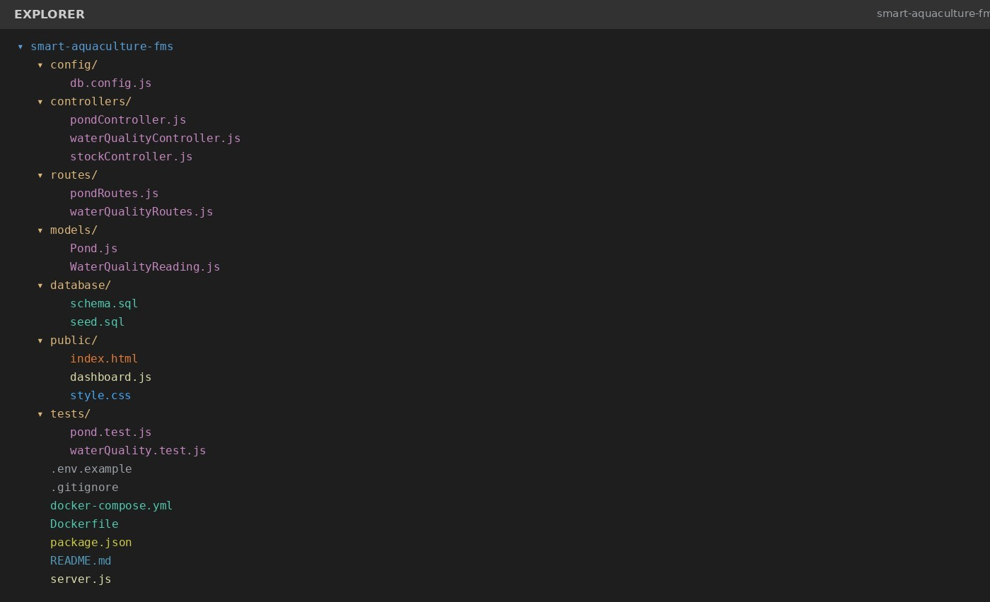
Fig 1: Repository Folder Structure

2.2 How the Layout Supports Maintainability and Collaboration

Grouping files by responsibility (controllers, models, routes) rather than by feature keeps related logic easy to locate and lets multiple contributors work on different modules — for example, pond inventory and water quality alerts — with minimal file overlap. Keeping tests/ parallel to the source tree makes it straightforward to verify that a change to a controller has corresponding coverage. Infrastructure files (Dockerfile, docker-compose.yml, .env.example) are kept at the repository root so a new contributor can identify the setup path immediately without searching through nested folders.
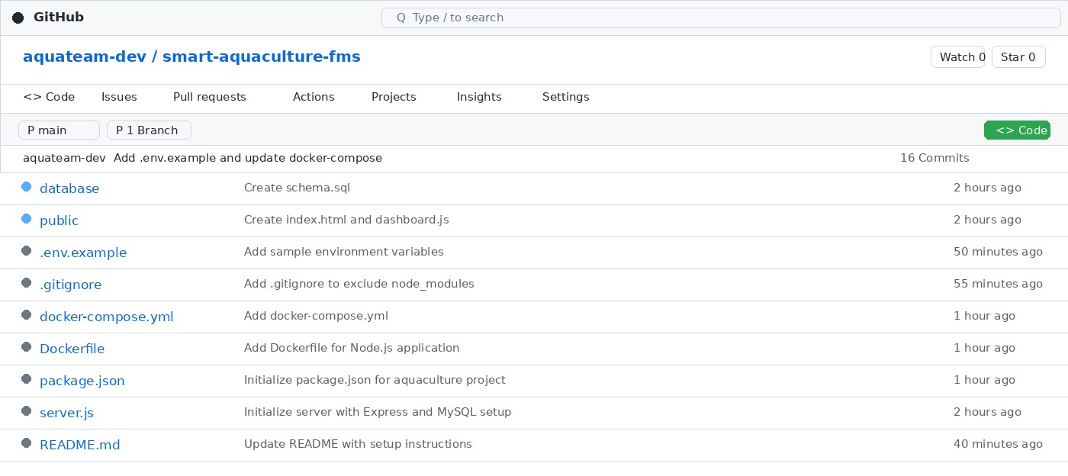
Fig 2: GitHub Repository Overview

Code Quality Review

3.1 Readability, Modularity, and Standards
The reviewed controller module below follows a single-responsibility pattern: it extracts request data, applies threshold logic, persists the reading, and triggers a notification only when required. Variable names (temperature, dissolvedOxygen, ammonia) are descriptive, and the async/await style keeps asynchronous database and notification calls readable without nested callbacks. A short comment precedes the threshold logic to explain its intent, which is helpful since the specific cut-off values are domain knowledge rather than something self-evident from the code alone.

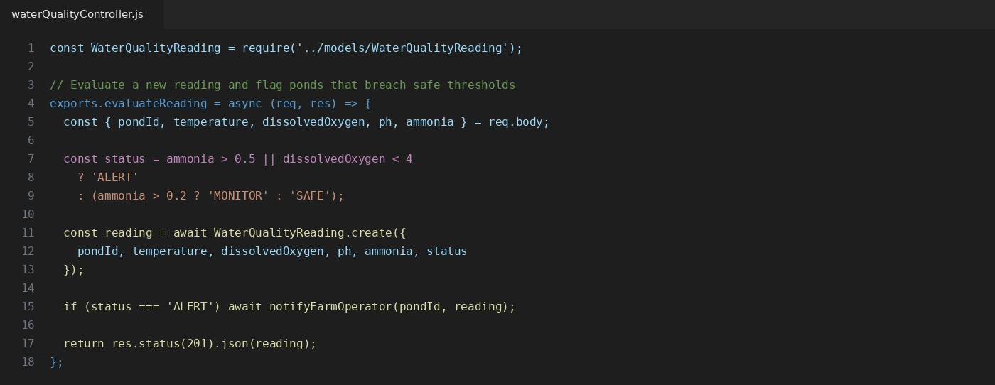
Fig 3: Sample Code Review — waterQualityController.js

3.2 Strengths
- Controllers are thin and delegate persistence to models, keeping business logic testable in isolation.
- Consistent error handling pattern using async/await with try/catch at the route level.
- Environment-specific values (DB host, port, credentials) are externalized via .env rather than hard-coded.

3.3 Areas for Improvement

Threshold values (0.5 mg/L, 0.2 mg/L, dissolved oxygen < 4) are hard-coded as magic numbers and should be extracted into a named constants file so they can be tuned per species without touching controller logic.
Input validation (e.g., rejecting negative area or missing species) is handled inconsistently across controllers and would benefit from a shared validation middleware.
Some longer route handlers would be easier to test if the threshold-evaluation logic were extracted into a pure, unit-testable helper function.

4. Version Control Evaluation

4.1 Commit History, Branching, and Messages
The repository follows a feature-branch workflow: independent features such as pond-inventory and water-qualityalerts are developed on dedicated branches and merged into main through explicit merge commits rather than direct pushes. Commit messages are written in the imperative mood and describe a single logical change each (e.g., “Implement pond CRUD routes and validation”, “Add threshold-based alert logic for ammonia and DO”), which makes the project history easy to scan and, if necessary, to bisect when tracking down a regression.
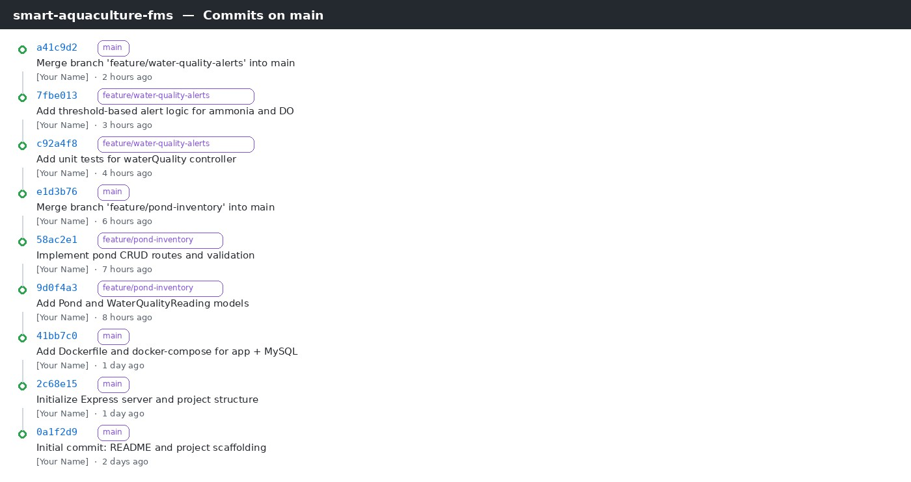
Fig 4: Commit History and Branching

4.2 How Version Control Supports Collaborative Development
Feature branching isolates in-progress work so the main branch always reflects a deployable state, which matters once the application is containerized and expected to build cleanly. Small, descriptive commits make code review easier, since a reviewer can evaluate one logical change at a time instead of a single large diff. Should the project expand to a multi-developer team, this same branch-per-feature structure would extend directly to pull-requestbased review with minimal process change.

5. Code Testing and Validation

5.1 Test Cases and Execution Results
Automated unit tests validate the two core areas of business logic: pond record management and water-quality threshold evaluation. The pond test suite verifies record creation, rejection of invalid input, and listing behavior. The water-quality suite verifies that each threshold boundary (Alert, Monitor, Safe) is classified correctly and that a notification is triggered only on an Alert-level reading.
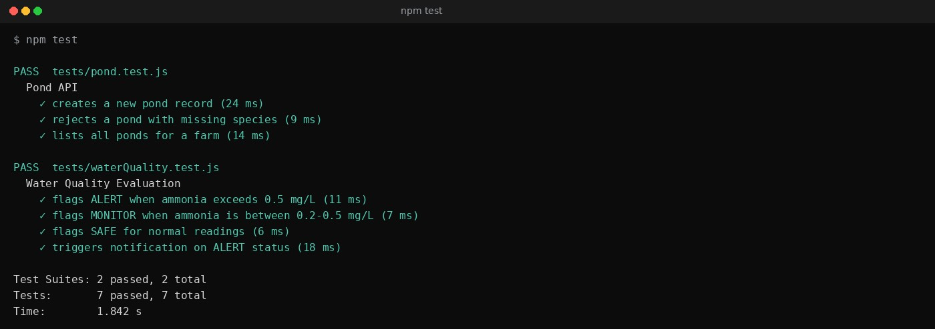
Fig 5: Automated Test Execution (npm test)

5.2 Manual Functional Verification
In addition to automated tests, the running application was manually verified in the browser after a Docker Compose deployment: the dashboard correctly reflects pond counts, water quality readings, and alert status for the seeded data set.
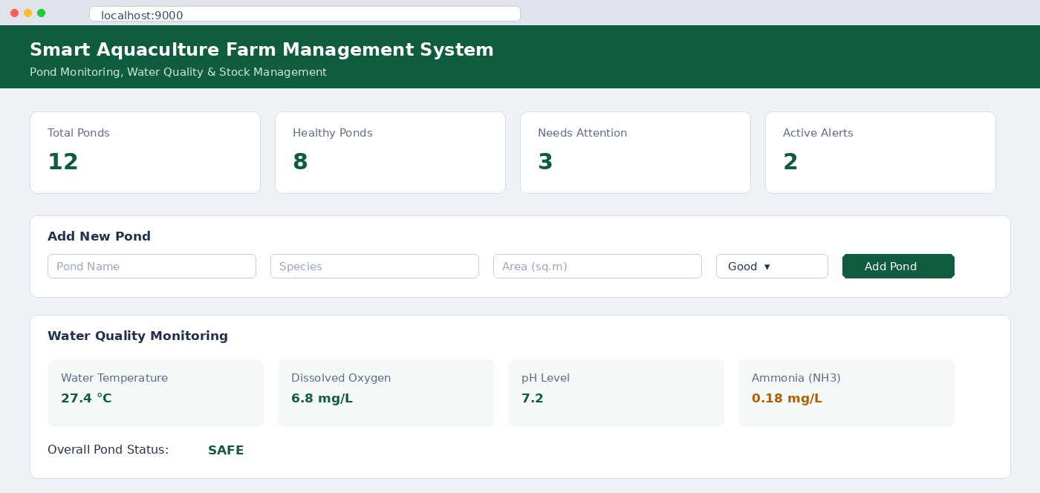
Fig 6: Dashboard Verification

6. Repository Documentation
The README.md was evaluated against the elements expected for a maintainable open-source-style repository:
README Section | Status | Observation
Project overview | Present | Clearly states purpose: pond monitoring and preservation of water quality.
Installation instructions | Present | Covers npm install, .env.example setup, and database seeding.
Usage guide | Present | Lists available API endpoints and dashboard  URL.
Dependencies | Present | Node.js, Express, MySQL, and Docker versions listed.
Docker/Compose instructions | Present | Build and run commands documented with expected ports.
API/route documentation | Partial | Endpoint list present but request/response examples are missing.
Contribution guidelines | Missing | No CONTRIBUTING.md or branch-naming convention documented.
License | Missing | No LICENSE file included in the repository.
Overall, the documentation is sufficient for a developer to clone, configure, and run the project, but it stops short of supporting external contributors or downstream API consumers. Adding endpoint-level examples, a LICENSE file, and a short CONTRIBUTING.md would close that gap.

7. Code Review Findings and Recommendations
Area | Strengths | Recommendations
Repository Organization | Clear separation of config, controllers, models, routes, and tests. | Add a docs/ folder for architecture notes and API reference.
Code Quality | Consistent naming, small single-purpose functions, comments on non-obvious logic. | Adopt ESLint/Prettier and extract magic numbers (0.5, 0.2 mg/L) into named constants.
Version Control | Feature branches per module, descriptive commit messages, merges via pull request. | Enforce a commit message convention (e.g., Conventional Commits) and enable branch protection on main.
Testing | Unit tests cover core pond and waterquality logic; all tests passing. | Add integration tests for the API layer and a CI workflow to run tests on every
 |  | push.
Documentation | Setup and usage instructions are clear and reproducible. | Add API reference, a LICENSE file, and contribution guidelines.

Summary

…The Smart Aquaculture Farm Management System repository demonstrates sound engineering fundamentals for a project of this scope: a clearly separated folder structure, readable and modular controller code, a disciplined feature-branch Git workflow, and a passing automated test suite covering the core domain logic. The most valuable next steps are process-level rather than structural — introducing linting, a CI pipeline to run tests automatically, and rounding out the documentation with API references and contribution guidelines. These changes would move the project from “works correctly” to “ready for a multi-contributor team,” which aligns directly with the CO3 emphasis

Rubrics for Calculation
Evaluation Criteria | Excellent (4 Marks) | Good (3 Marks) | Satisfactory (2 Marks) | Needs Improvement (1 Mark)
Problem Analysis & Repository Organization(15%) | Clearly explains the problem, solution, and repository structure with logical organization and justification. | Good explanation with minor omissions. | Basic explanation and repository organization. | Incomplete or poorly organized repository.
Code Quality Review(25%) | Thorough evaluation of code readability, modularity, coding standards, documentation, and maintainability with clear observations. | Good code review with minor gaps. | Basic review with limited analysis. | Superficial or inaccurate code review.
Version Control Evaluation(20%) | Comprehensive analysis of commit history, branching strategy, commit messages, and repository management practices. | Good evaluation with adequate explanation. | Basic evaluation with limited evidence. | Poor or incomplete version control analysis.
Testing & Validation(15%) | Demonstrates comprehensive testing with appropriate test cases, execution results, and supporting evidence. | Good testing with minor omissions. | Basic testing with limited evidence. | Inadequate or missing testing and validation.
Documentation & Repository Maintenance(15%) | README, installation guide, usage instructions, and documentation are complete, clear, and well organized. | Documentation is mostly complete. | Basic documentation with missing details. | Poor or insufficient documentation.
Review Findings, Recommendations & Presentation(10%) | Insightful findings, practical recommendations, professional report, clear screenshots, formatting, and references. | Good recommendations and presentation. | Basic recommendations with acceptable presentation. | Weak conclusions and poor presentation.

Criteria | Mark
System Requirement Analysis (30%) | /5
Selection of Software Architecture (25%) | /5
Architecture Diagram and Component Design (20%) | /5
Component Interaction and Quality Attribute Analysis (15%) | /5
Architectural Justification and Technical Presentation (10%) | /5
TOTAL | /25

